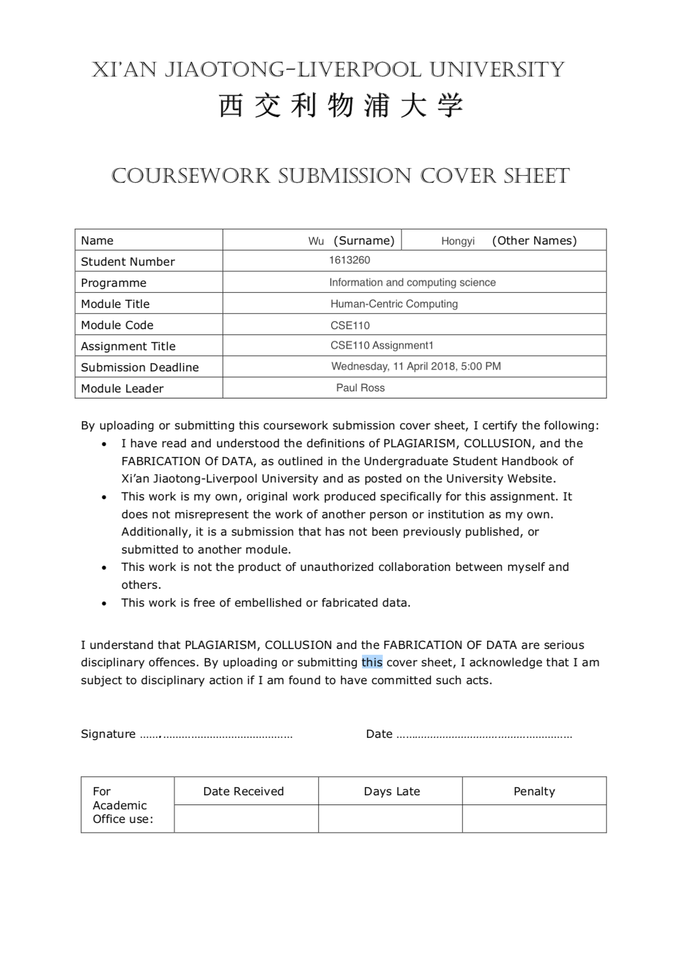

**CSE110 Assignment1 Report**

**Hongyi Wu**

**1613260**

**Link of Website:**

**http://10.7.1.126/student/Hongyi.Wu16/myweb/**

Source Code:

**Index.html**

<!--CSE110:Aassignment 1-->

<!--Hongyi Wu-->

<!--1613260-->

<!--File:index.html-->

<!DOCTYPE html>

<html lang="en">

<head>

<meta charset="UTF-8">

<meta name="keywords" content="Hongyi Wu, Year 2, CSSE, XJTLU">

<meta name="author" content="Hongyi Wu">

<title>Home Page</title>

<link rel="stylesheet" href="main.css" type="text/css" media="screen" />

<link href="https://fonts.googleapis.com/css?family=Exo" rel="stylesheet">

</head>

<body>

<!--a top bar menu always fix on top-->

<div class="topbar">

<ul class="toplist">

<!--list used in this-->

<li class="left"><a href="index.html"><strong>Home Page</strong></a></li>

<li class="left"><a href="index.html#information">Personal Information</a></li>

<li class="right"><a href="http://www.xjtlu.edu.cn/en/">XJTLU</a></li>

<li class="right"><a href="index.html#outlook">Outlook</a></li>

<li class="right"><a href="index.html#interest">My Interests</a></li>

<li class="right"><a href="index.html#childhood">My Childhood</a></li>

</ul>

</div>

<!--My name and photo centred in page-->

<div id="me">

<div id='leftface'>

<img src="myface.png" width="100" alt="me">

</div>

<div id='rightname'>

<h1>Hongyi Wu</h1>

</div>

</div>

<!--Personal information displays by list-->

<div id="information">

<h2>Personal information</h2>

<br>

<div id="lists">

<ul>

<li>Hongyi Wu, a student in XJTLU, Suzhou.</li>

<li>From Hefei, Anhui, China. </li>

<li>Major in <a href="http://www.xjtlu.edu.cn/en/departments/academic-departments/computer-science-and-software-engineering/">Information and Computing Science</a>.</li>

<li>Student ID, 1613260.</li>

</ul>

</div>

<br>

<p>You can never really learn about me through these information.</p>

<p>Also, I come to understand myself by the assignment,

<p>thus figuring out what is my favourite, and what a person I actually want to be.</p>

</div>

<hr>

<!--another part, my childhood-->

<div id="childhood">

<h2>My childhood</h2>

<img src="childhood.png" width="400" alt="childhood">

<h3>Cultivated my character in childhood</h3>

<br>

<p>I often stayed alone,building with blocks, or watching how insects move.</p>

<p>I also found painting appealing, learning about watercolor and wash painting correspondingly.</p>

<p>What I had learned brings me the source of innovation, for which I am impassioned.</p>

<p>I supposed that I would be a scientist.</p>

</div>

<!--show my interest by table-->

<div id="interest">

<h2>My interests</h2>

<div id="join">

<div id="leftphoto"><img src="http://www.arenapersonnel.com/wp-content/uploads/2016/09/17631320-doodle-hobby-images-Stock-Vector.jpg" alt="hobbies"></div>

<div id="rightcontent">

<p>As I grew up, I come to appreciate audio and visual arts.</p>

<p>The following table shows several productions and their rank.</p>

<br>

</div>

</div>

<table class="rank">

<thead>

<tr>

<th>Category</th>

<th>#1</th>

<th>#2</th>

<th>#3</th>

</tr>

</thead>

<tr>

<td>Games</td>

<td>MOBA</td>

<td>MMORPG</td>

<td>ARPG</td>

</tr>

<tr>

<td>Music</td>

<td>Ballad</td>

<td>Musicals</td>

<td>Rock and Roll</td>

</tr>

<tr>

<td>Films</td>

<td>Sci-Fi</td>

<td>Suspense</td>

<td>Documentary</td>

</tr>

</table>

<br>

<p id="production">Here is my preferred productions!</p>

<hr>

<br>

<br>

<!--three picture of my preferred productions-->

<div>

<div class="card">

<img src="ballad.jpeg" style="width:100%" alt="zhifei">

<div class="container">

<p>Ballad: Zhi Fei</p>

</div>

</div>

<div class="card">

<img src="mozart.jpg" style="width:100%" alt="mozart">

<div class="container">

<p>Musical: Mozart!</p>

</div>

</div>

<div class="card">

<img src="zed.jpg" style="width:100%" alt="zed">

<div class="container">

<p>Game:League of Legends</p>

</div>

</div>

</div>

</div>

<!--last part of my future-->

<div id="outlook">

<h2>Outlook</h2>

<p>I come to feel like learning computer as my major.</p>

<p>In my opinion, being faced with computer symbolizes how a person deals with objects.</p>

<p>In addition, it is also important to deal with interpersonal relationships and communication with people.</p>

<p>I will leave for <a href="https://www.liverpool.ac.uk">UOL</a> next semester. It will be my new journey of life.</p>

<p>As for my future work, maybe related to computer <i>regarding data analysis</i> or <i>machine learning</i>, maybe not. </p>

<p id="know">Who knows?</p>

<br>

</div>

<!--an end bar to show my work-->

<div class="endbar">

<p><br>Made by <strong>Hongyi Wu</strong><br>10th April 2018.</p>

<br>

</div>

</body>

</html>

main.css

/*CSE110:Aassignment 1

Hongyi Wu

1613260

File:main.css*/

/*change the front to EXO and center all the characters*/

body {

font-family: 'Exo', sans-serif;

text-align: center;

}

p {

font-size: 20px;

}

/*change the dfault style of the underline of the link and the color of font */

.topbar a {

color: white;

text-decoration: none;

}

.topbar li {

margin: 0 0 0 40px;

padding: 3px;

font-size: 20px;

}

/*fix the topbar and change the opacity to be beautiful*/

.topbar {

width: 100%;

height: 50px;

display: inline-block;

background: #009688;

position: fixed;

top: 0;

left: 0;

z-index: 1;

filter: alpha(opacity=60);

-moz-opacity: 0.7;

opacity: 0.7;

box-shadow: inset 5px 5px 4px 0px rgba(151, 24, 64, 0.2);

}

/*change the left and right respectively*/

.topbar .left {

float: left;

list-style-type: none;

padding-bottom: 1%;

}

.topbar .right {

float: right;

list-style-type: none;

padding-right: 2%;

padding-bottom: 1%;

}

/*change the font to georgia*/

h1 {

text-align: center;

font-family: Georgia;

font-size: 30px;

}

/*choose a position to fix my face*/

#me {

z-index: 2;

position: absolute;

height: 100px;

top: 0px;

width: 100%

}

#leftface img {

border-radius: 50%

}

#rightname {

margin-top: 10px;

}

#information {

width: 100%;

margin-top: 150px;

margin-bottom: 80px;

}

/*make an underline by setting the border*/

h2 {

font-size: 30px;

font-style: normal;

width: 25%;

height: 60px;

border-width: 0 0 1px 0;

border-style: solid;

border-color: #E0E0E0;

}

#lists {

width: 30%;

margin: auto;

}

/*change the style of the list to beautify it */

#information ul {

list-style-type: circle;

font-size: 20px;

font-family: 'Times';

font-style: italic;

}

/*change the style of hr to make it beautiful */

hr {

width: 70%;

border: 0;

border-top: 1px solid rgba(0, 0, 0, 0.1);

border-bottom: 1px solid rgba(255, 255, 255, 0.3);

}

#childhood {

width: 100%;

}

#childhood img {

width: 600px;

}

#childhood h3 {

font-family: Tahoma;

}

#interest {

width: 100%;

margin-bottom: 500px;

}

#join {

position: relative;

width: 100%;

}

#leftphoto {

position: absolute;

top: 2px;

left: 4px;

}

/*fix the interest picture*/

#leftphoto img {

height: 200px;

width: 200px;

margin-left: 120px;

border: 1px solid #ccc;

padding: 2px;

}

#rightcontent {

margin-left: 0px;

}

/*change the font of description of the picture*/

.rank {

font-family: "Tahoma";

width: 50%;

margin: 0 auto;

}

/*beautify the table to suit my webpage*/

.rank td, .rank th {

padding: 10px;

border-bottom: 1px solid #f2f2f2;

}

/*change the color of the even row*/

.rank tbody tr:nth-child(even) {

background: #f5f5f5;

}

.rank th {

text-shadow: 0 1px 0 rgba(255, 255, 255, .5);

border-bottom: 1px solid #ccc;

background-color: #5dbeab;

}

#production {

font-size: 30px;

font-weight: bold;

font-style: italic;

}

/*make a card effect to display my productions*/

.card {

float: left;

margin-left: 10%;

font-family: "Arial";

width: 20%;

box-shadow: 0 4px 8px 0 rgba(0, 0, 0, 0.2), 0 6px 20px 0 rgba(0, 0, 0, 0.19);

text-align: center;

}

div.container {

padding: 10px;

}

/*change the style of line to separate*/

#interest hr {

border: 0;

height: 1px;

background-image: linear-gradient(to right, rgba(0, 0, 0, 0), rgba(0, 0, 0, 0.75), rgba(0, 0, 0, 0));

width: 60%;

}

#outlook {

width: 100%;

margin-top: 150px;

margin-bottom: 80px;

}

/*change the default color of the link */

#outlook a {

color: #009688;

text-decoration: none;

}

/*change the style of "who knows?" */

#know {

font-size: 30px;

font-weight: bold;

font-style: italic;

}

/*make an end bar to show my name and date */

.endbar {

width: 100%;

max-height: 20%;

color: white;

background: #5bb5ab;

padding: 1;

box-shadow: inset 5px 5px 4px 0px rgba(151, 24, 64, 0.2);

}

.endbar p {

margin-left: 3%;

text-align: left;

}

**Screen Shots:**

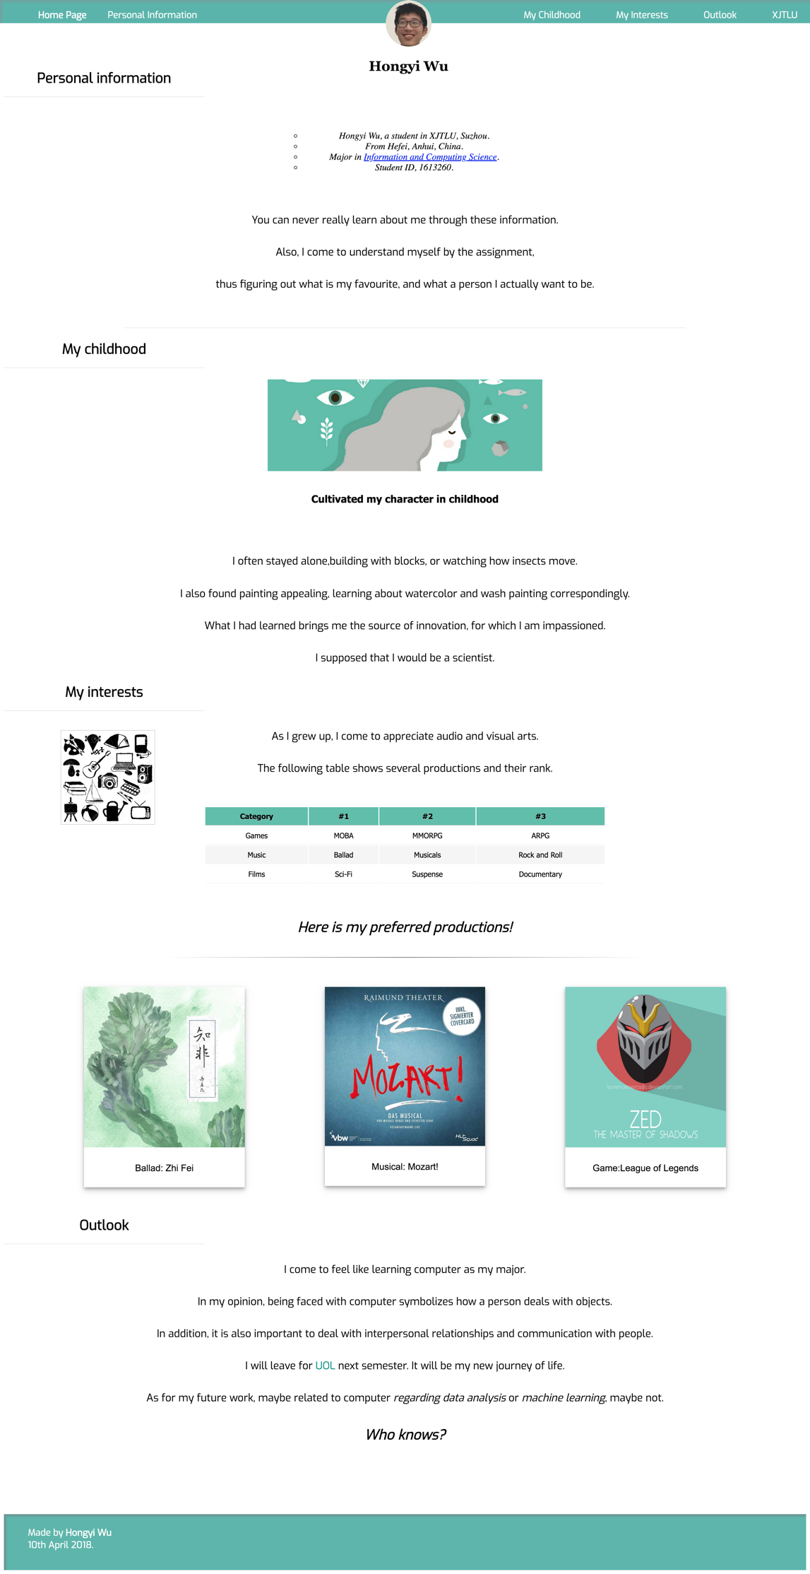



This the top bar and my face/name centered on screen. You can click the five buttons to view the page and the external link. You can see the top bar anywhere you view the page!

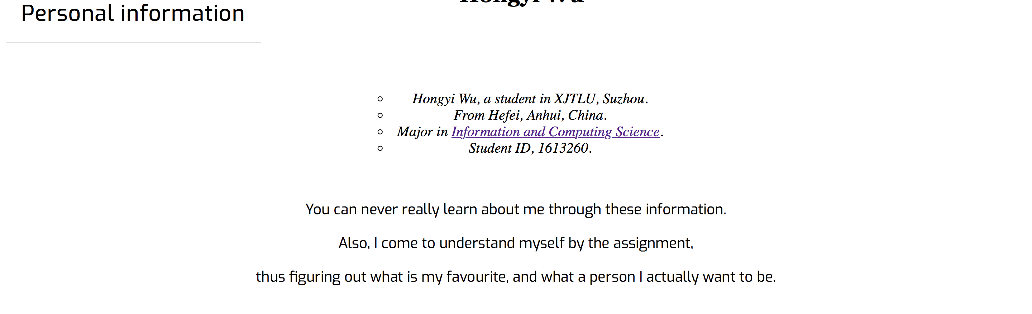

My personal information, there is a list including a hyperlink.

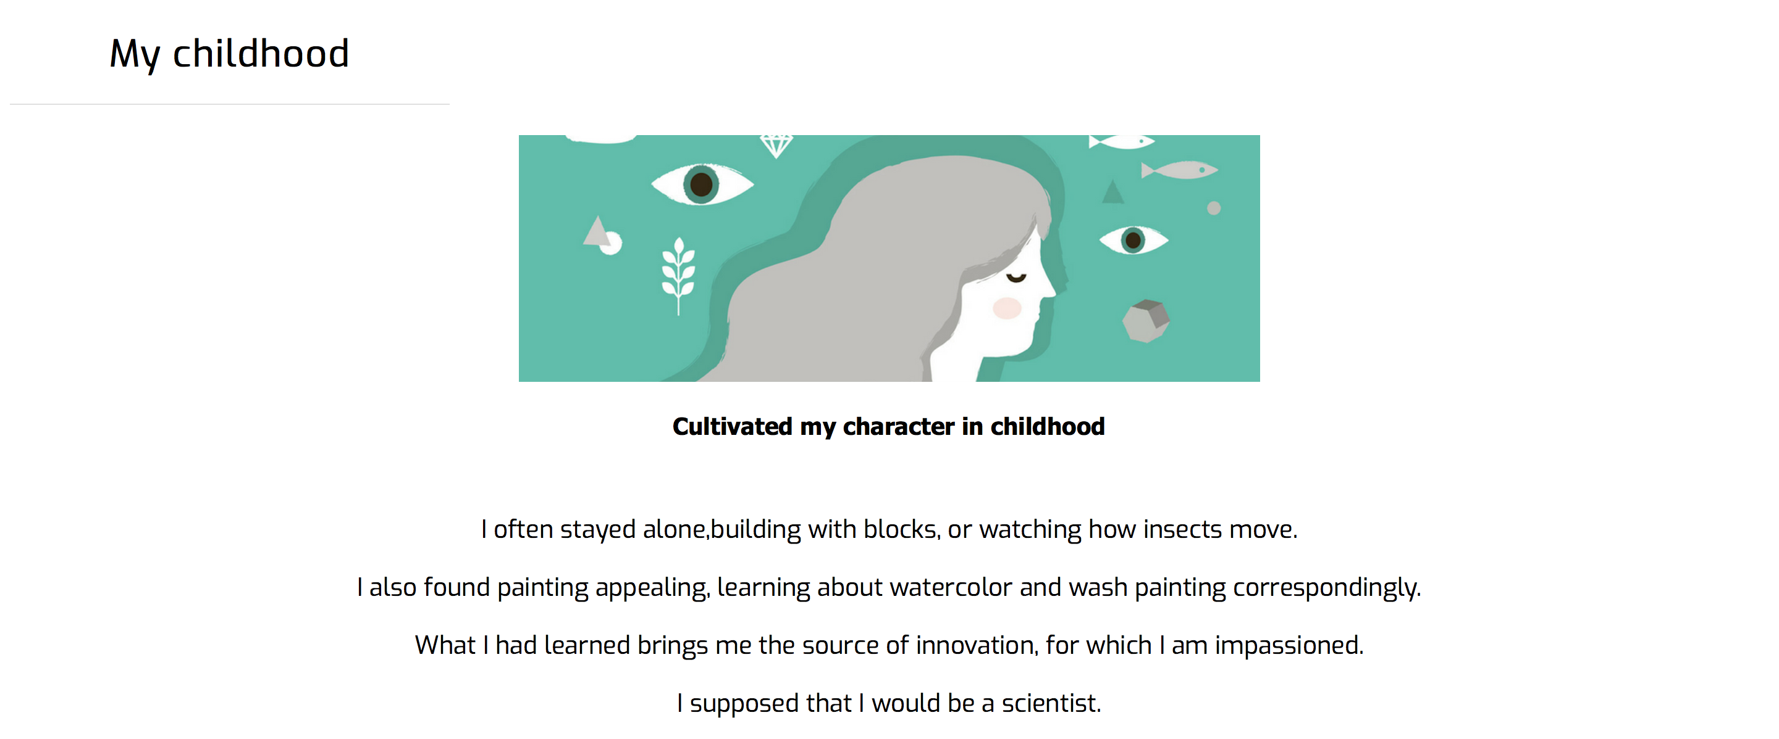

My childhood part, which inserts a picture and introduce my childhood.

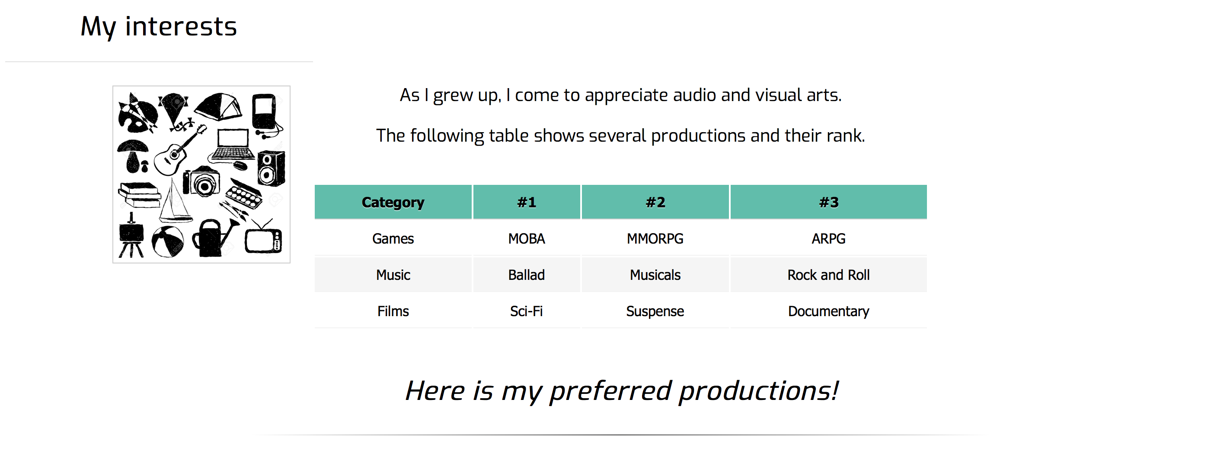

A table shows my preferred productions.

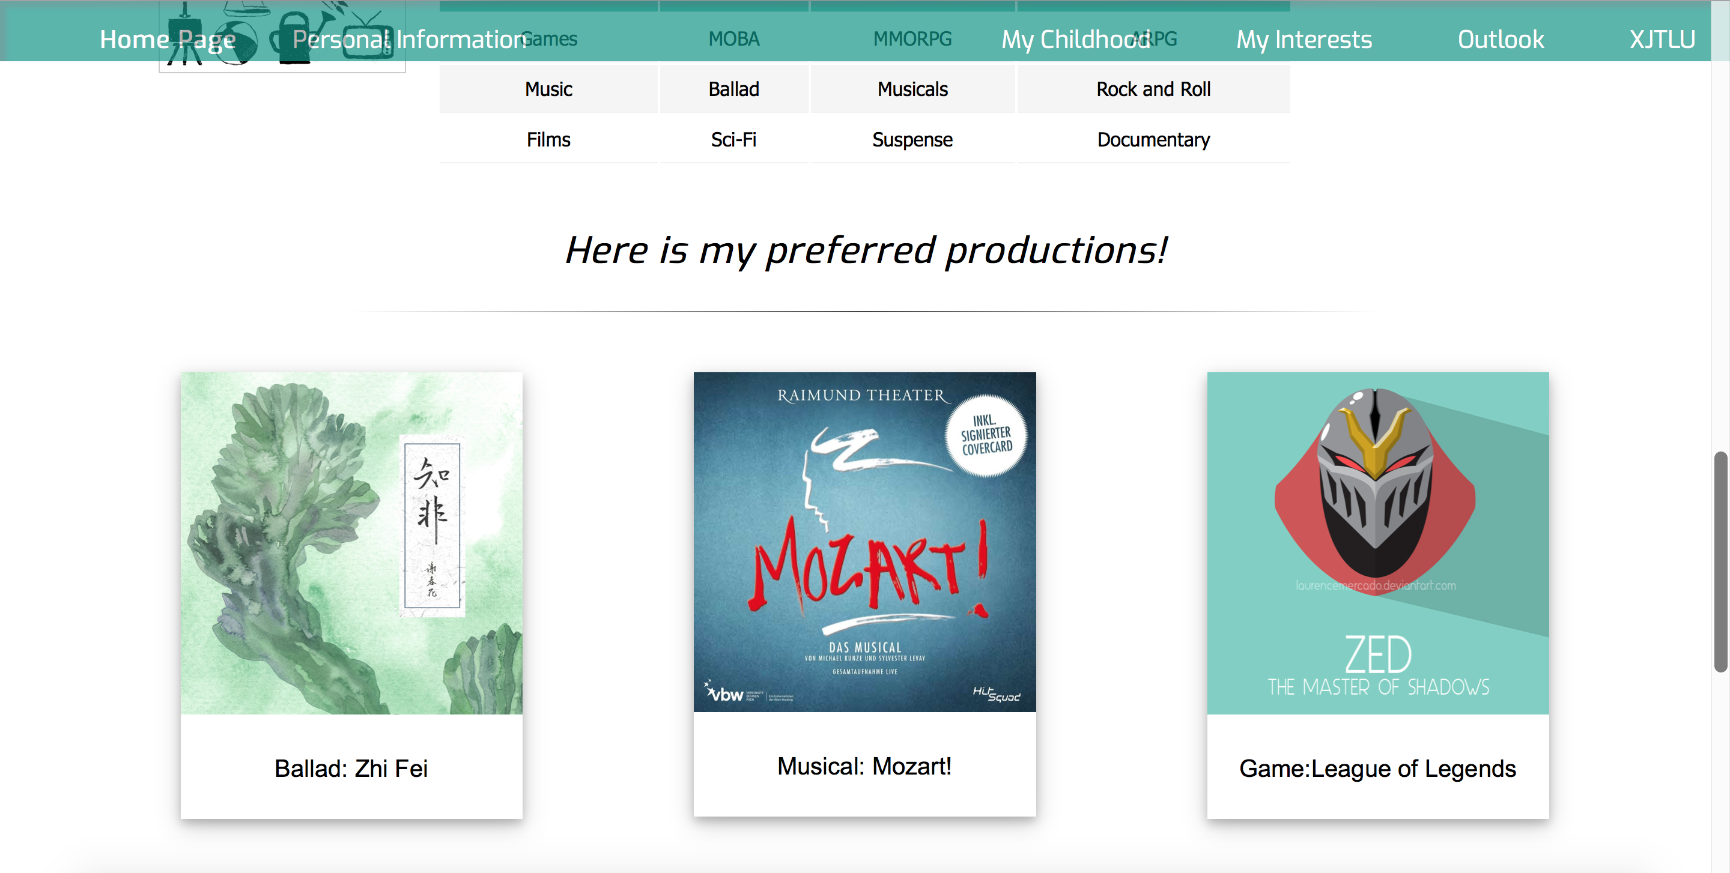

Three pictures inserted.

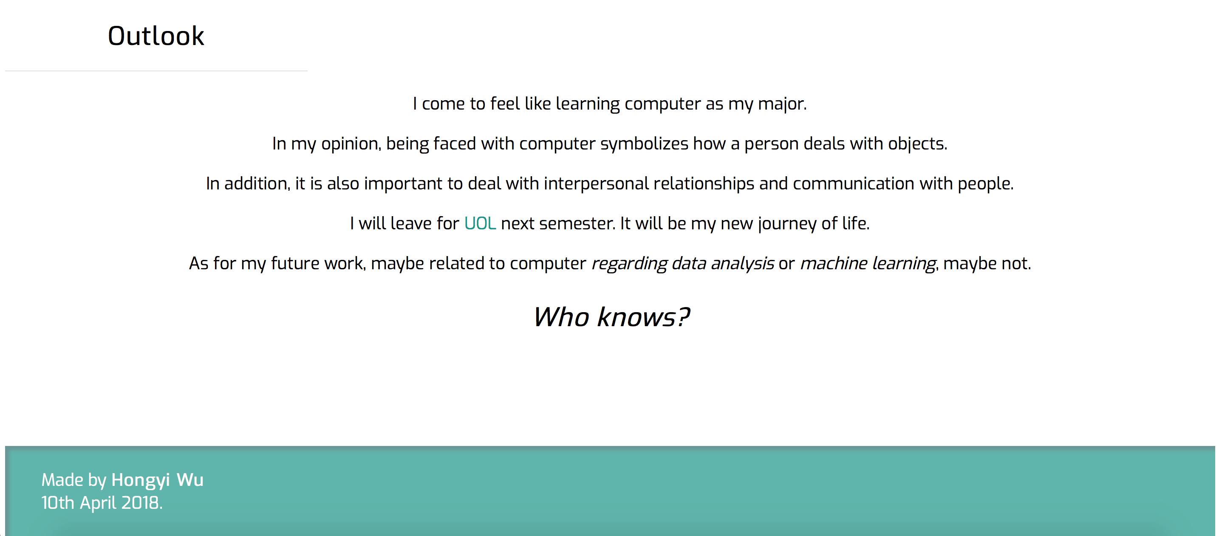

The outlook of my future and the name/date in the last of the page.

HTML Validator:

